**Question 2**

Your task is to perform the steps of logical database design, i.e. to transform a conceptual schema given above into a collection of relational schemas. Before transforming add the attribute ‘date-made’ to the BUS class and ‘home-city’ to the DRIVER class. Draw the resulting conceptual schema adding your name, student number and the date to the drawing. Use UMLet and paste images of your drawings into your Microsoft Word document using the template provided. List the names of attributes, primary key, candidate keys (if any), and foreign keys (if any) for each class in the relational schema. Assume that an association method is used to implement the generalization. Show your working and explain as you step through the transformation process.

Answer 2.

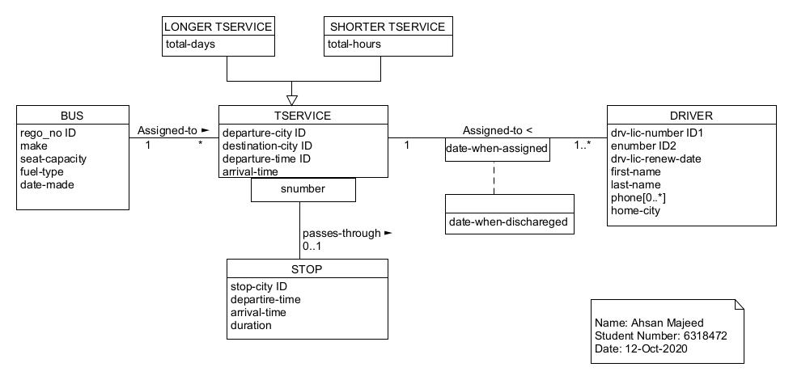

***Figure 1. Modified ER Diagram of Conceptual Schema***

Added **date-made** field in BUS class and **home-city** field in DRIVER class.

In order to transform a conceptual schema given above into a collection of relational schemas, following steps are performed in a given order below:

Fisrstly I have created a table named as 'TSERVICE' having fields - service number which is the primary key of table

along with the departure city and destination city id and departure and arrival time.

CREATE TABLE TSERVICE(

TSERVICENUM DECIMAL(12) NOT NULL,

DEPARTURE_CITY DECIMAL(12) NOT NULL,

DESTINATION_CITY DECIMAL(12))NOT NULL,

DEPARTURE_TIME VARCHAR(50) NOT NULL,

ARRIVAL_TIME VARCHAR(50) NOT NULL,

CONSTRAINT TSERVICE_PKEY PRIMARY KEY(TSERVICENUM) );

/* ~~~~~~~~~~~~~~~~~~~~~~~~~~~~~~~~~~~~~~~~~~~~~~~~~~~~~~~~~~~~~~~~~~~~~~~~~~~~~~~~~~~~~~~~~~~~~~~~~~~~~~~~~~~~~~~~ */

Then service table is further normalized ino longer trip service and shorter trip services and which stores the total days in longer services while total hours in shorter services

respectively. Both the tables has primary key of TSERVICE table as foreign key for reference.

CREATE TABLE LONGER_TSERVICE(

TLONGER_SERVICENUM DECIMAL(12) NOT NULL,

TSERVICENUM DECIMAL(12) NOT NULL,

TOTAL_DAYS VARCHAR(50) NOT NULL,

CONSTRAINT LONGER_TSERVICE_PKEY PRIMARY KEY(TLONGER_SERVICENUM),

CONSTRAINT LONGER_TSERVICE_FKEY FOREIGN KEY(TSERVICENUM) REFERENCES TSERVICE(TSERVICENUM) );

/* ~~~~~~~~~~~~~~~~~~~~~~~~~~~~~~~~~~~~~~~~~~~~~~~~~~~~~~~~~~~~~~~~~~~~~~~~~~~~~~~~~~~~~~~~~~~~~~~~~~~~~~~~~~~~~~~~ */

CREATE TABLE SHORTER_TSERVICE(

TSHORTER_SERVICENUM DECIMAL(12) NOT NULL,

TSERVICENUM DECIMAL(12) NOT NULL,

TOTAL_HOURS VARCHAR(50) NOT NULL,

CONSTRAINT SHORTER_TSERVICE_PKEY PRIMARY KEY(TSHORTER_SERVICENUM),

CONSTRAINT SHORTER_TSERVICE_FKEY FOREIGN KEY(TSERVICENUM) REFERENCES TSERVICE(TSERVICENUM) );

/* ~~~~~~~~~~~~~~~~~~~~~~~~~~~~~~~~~~~~~~~~~~~~~~~~~~~~~~~~~~~~~~~~~~~~~~~~~~~~~~~~~~~~~~~~~~~~~~~~~~~~~~~~~~~~~~~~ */

Further, each trip is carried out by a driver so we are maintaining individual DRIVER table in order to record the basic information about the driver.

CREATE TABLE DRIVER(

DRI_LIC_NUMBER DECIMAL(12) NOT NULL,

ENUMBER DECIMAL(8) NOT NULL,

DRI_LIC_RENEW_DATE DATE NOT NULL,

FIRSTNAME VARCHAR(50),

LASTNAME VARCHAR(50),

PHONE DECIMAL(12) NOT NULL,

HOME_CITY VARCHAR(50),

CONSTRAINT DRIVER_PKEY PRIMARY KEY(ENUMBER),

CONSTRAINT DRIVER_UNIQUE UNIQUE(DRI_LIC_NUMBER));

/* ~~~~~~~~~~~~~~~~~~~~~~~~~~~~~~~~~~~~~~~~~~~~~~~~~~~~~~~~~~~~~~~~~~~~~~~~~~~~~~~~~~~~~~~~~~~~~~~~~~~~~~~~~~~~~~~~ */

Along with the driver, buses information are also stored in separate table.

CREATE TABLE BUS(

REGO_NO DECIMAL(12) NOT NULL,

MAKE VARCHAR(50),

SEAT_CAPACITY DECIMAL(12) NOT NULL,

FUEL_TYPE VARCHAR(50) NOT NULL,

DATE_MADE DATE NOT NULL,

CONSTRAINT BUS_PKEY PRIMARY KEY(REGO_NO));

/* ~~~~~~~~~~~~~~~~~~~~~~~~~~~~~~~~~~~~~~~~~~~~~~~~~~~~~~~~~~~~~~~~~~~~~~~~~~~~~~~~~~~~~~~~~~~~~~~~~~~~~~~~~~~~~~~~ */

I have also created a separate STOP table as mentioned in the conceptual schema for storing stoppage related information of the trips.

CREATE TABLE STOP(

STOP_ID DECIMAL(12) NOT NULL,

STOP_CITY DECIMAL(12) NOT NULL,

DEPARTURE_TIME VARCHAR(50) NOT NULL,

ARRIVAL_TIME VARCHAR(50) NOT NULL,

DURATION VARCHAR(50) NOT NULL,

CONSTRAINT STOP_PKEY PRIMARY KEY(STOP_ID));

/* ~~~~~~~~~~~~~~~~~~~~~~~~~~~~~~~~~~~~~~~~~~~~~~~~~~~~~~~~~~~~~~~~~~~~~~~~~~~~~~~~~~~~~~~~~~~~~~~~~~~~~~~~~~~~~~~~ */